**Options to create repository for SQL(or other code files):**

1. **Using TortoiseSVN (subversion)**
2. **Using SVN plugin ()**
3. **Git hub**
4. **ApexSQL Source Control**
5. **TFS**

* **Using TortoiseSVN to create repository for SQL and other code files**

**Steps:-**

1. **Download the latest version of TortoiseSVN (Comes in 32 bit and 64 bit versions)** [**http://www.wandisco.com/subversion/download#tortoise**](http://www.wandisco.com/subversion/download#tortoise)

Terminology related to :

* 1. **URL Repository:** This is the URL of the repository on which you want to work. This is the address of the repository, or portion of a repository for which you want to make a working copy. You can get the repository URL from the repository's screen in uberSVN:
  2. **Checkout directory:** This is the location on your local file system where the checkout will occur. By default it will be the location that you're currently focused on in Explorer, however you can change it here.
  3. **Checkout Depth:** The Checkout Depth drop-down allows you to limit what you checkout. Useful if you only want to make a change in one directory of a very large repository.
  4. **Revision:** You can get the latest version of the repository, called 'HEAD' (most up-to-date version), or select a specific revision to go back to a version before particular changes.
  5. When you've finished with these options and you're ready to do the checkout, click OK.
* **Creating SQL server repository using SVN**

Agent SVN plug-in allows you to seamlessly integrate Microsoft SSMS with Subversion

**Version Supported for SSMS** => 2008-2014 (*for 2017 some tweaking is required-* [*http://www.zeusedit.com/agent/ide/ssms/ssms2017-setup.html*](http://www.zeusedit.com/agent/ide/ssms/ssms2017-setup.html))

Below is the list of steps required to use SVN setup:

1. Agent SVN Provider Setup

SSMS IDE 🡪 Tools 🡪 Options 🡪 Source Control 🡪Select “Agent SVN” from dropdown

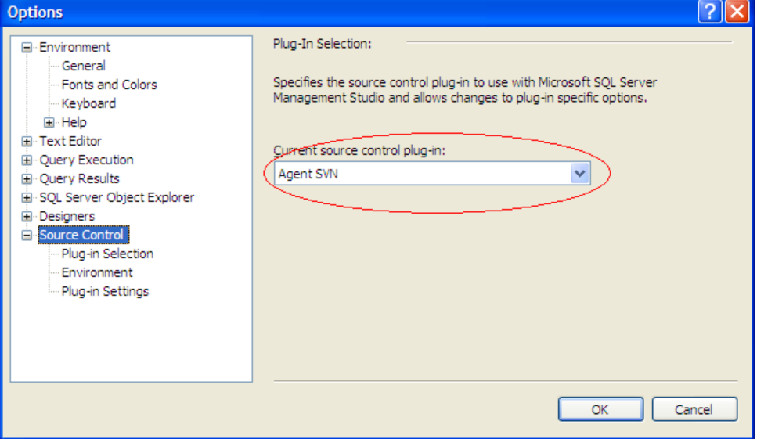

1. Configure Agent SVN

SSMS IDE🡪File🡪Source Control🡪Launch Agent SVN

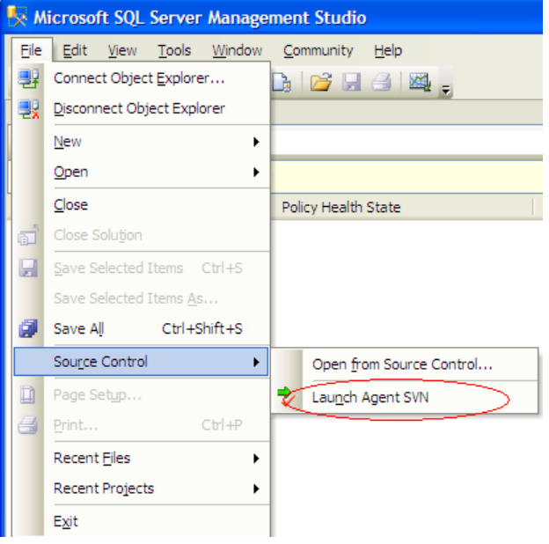

For this initial testing use the *Folder* entry field to define the location of a local Subversion repository and select the *Local File* protocol as shown below:

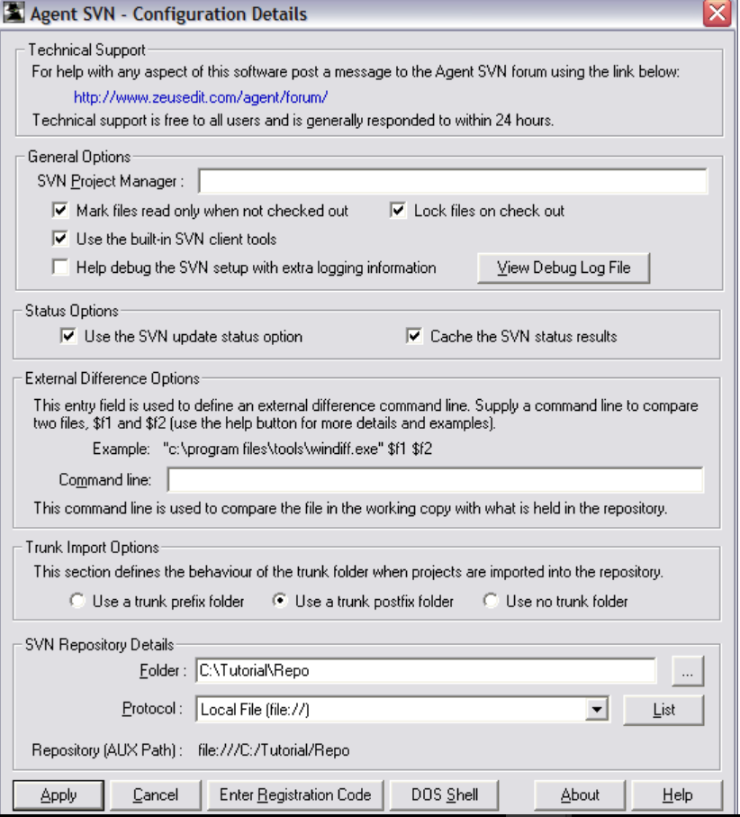

1. Create a Test SQL Project

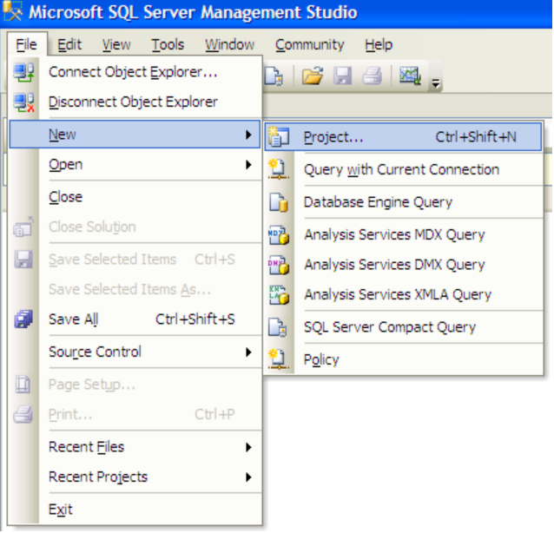

To see how Agent SVN works we need something to play with so the next step is to create a simple test project.From within Microsoft SQL Server Management Studio IDE create a new My Scripts project as shown above

**Reference - http://www.zeusedit.com/agent/ide/ssms/ms_ssms.html**